Part 1: Motivation
- Topic: Build an LLM-based financial news tagger that converts financial headlines into structured risk signals
  - Use prompt-engineered LLMS to output tags such as company, event type, risk category, and sentiment, and evaluate reliability using classification metrics including precision, recall, F-1 score, and accuracy.
- Research Question: Can a prompt-engineered LLM- based system extract structured financial risk signals from financial news headlines, and does few-shot prompting improve performance compared to zero-shot prompting?
- Why it's important/unique:
  - Financial markets are increasingly influenced by the vast streams of textual data, making accurate and timely sentiment analysis crucial for investment decisions. Nuanced language in financial markets requires deeper contextual understanding.
  - Traditional financial NLP research focuses primarily on sentiment classification, but this does not capture the type or source of risk embedded in financial news
  - Goes beyond sentiment analysis to multi-dimensional risk categorization(event type, risk category)
  - Quantitatively evaluates generative model performance.
  - Evaluates the generative model's output quality using classification metrics and provides a quantitative benchmark.
  - The model makes the approach efficient and cost-effective without fine-tuning.

Part 2: Related Works
At least 2 works. Summarize methods, strengths, and limitations. Cite properly.
- What do LLMs Know about Financial Markets? A Case Study on Reddit Market Sentiment Analysis
  - Investigates the use of LLMs to bootstrap a market sentiment analysis model for social media content with minimal human annotation efforts
  - Methods: To annotate Reddit posts with weak financial sentiment labels, the paper uses LLM in-context learning with Chain-of-Thought reasoning and repeated generation for more stable predictions.
  - Strength: The model that is fine-tuned on weakly labeled Reddit data, is able to effectively transfer the knowledge from the LLM and outperform all supervised baselines on the Reddit dataset. At the same time, the model generalizes well to the FiQA(Financial Opinion Mining and Question Answering) dataset despite only being fine-tuned on Reddit posts.
  - Limitations: the paper only does sentiment classification (positive/negative/neutral), not multi-dimensional risk tagging.
  - Citation: Deng, X., Bashlovkina, V., Han, F., Baumgartner, S., & Bendersky, M. (2023). What do llms know about financial markets? A case study on reddit market sentiment analysis. Companion Proceedings of the ACM Web Conference 2023, 107–110. https://doi.org/10.1145/3543873.3587324
- A Prompt Engineering Approach for Structured Data Extraction from Unstructured Text Using Conversational LLMs
  - The paper uses a prompt engineering approach using conversational LLMs for extracting the relevant information related to travel and storing the information into relational databases, which is queried using SQL.
  - Methods: Use ChatGPT and BARD to extract travel information from email texts by employing a single prompt. Conduct experiments on different methods of prompting(Standard prompting, Interactive refinement prompting, Chain of thoughts prompting, Persona pattern prompting) for trip extraction from the unstructured text data.
  - Strength: The BARD model, particularly when combined with the Persona, Chain of Thought, Few-shot, or Iterative methods, delivered enhanced performance with varying tradeoffs between recall and precision. These findings emphasize the importance of utilizing diverse approaches to develop more effective and reliable chatbot systems.
  - Limitation: The model is applied to a general domain (travel emails) not finance. The project will extend Vijayan's methodology into the financial domain with a multi-dimensional label schema.
  - Citation: Vijayan, A. (2023). A prompt engineering approach for structured data extraction from unstructured text using conversational llms. 2023 6th International Conference on Algorithms Computing and Artificial Intelligence, 183–189. https://doi.org/10.1145/3639631.3639663

Part 3: Methodology
Planned Methods:
For this project, we plan to use a prompt-engineered large language model to extract structured financial risk signals from news headlines. The model will take a headline as input and generate structured outputs, including:
- Company name
- Event type
- Risk category
- Sentiment
The outputs will be returned in a structured format (ex.JSON, CSV) so that they can be easily evaluated and compared with true labels.
- Zero-shot prompting, where the model receives task instructions but no examples
- Few-shot prompting, where the prompt includes a small number of labeled examples to guide the model
- Maybe a chain of thought prompting to encourage step-by-step reasoning to see if it improves consistency
We can compare these and see whether providing example labels improves the model’s ability to extract structured financial risk signals from news headlines.

Why This Is Appropriate:
Financial headlines are short but information-dense, which makes them work well for LLM-based extraction (we hope so). Since modern LLMs are trained on large-scale text data, they are likely to already have some understanding of financial terminology and event types. So, using prompt engineering instead of fine-tuning can allow us to:
- Evaluate the generalization of LLMs
- Reduce computational cost
- Compare zero-shot vs few-shot prompting
Because our task focuses on extracting structured labels rather than generating free-form text, prompt design plays an important role in ensuring consistent outputs.

Course Tools and Techniques:
- Prompt engineering
- In-context learning
- Zero-shot prompting
- Few-shot prompting
- Chain of thought prompting (maybe)
- LLM application development
- Evaluation metrics (the usual ones like precision, recall, F-1 score, accuracy)

Evaluation Plan:
Although the model generates text outputs, we will evaluate the results as classification tasks for each predicted field (event type, risk category, sentiment). We will manually annotate a subset of headlines with the correct labels. These manually created labels will serve as the reference labels for evaluation. We will then compare the model’s predictions with the reference labels provided by the dataset and compute the evaluation metrics. These should be able to measure how accurately the model extracts financial risk signals from headlines. Then we will compare the performance of zero-shot prompting and few-shot prompting to determine whether providing labeled examples improves the accuracy of extraction. This will also help analyze common types of errors and observe whether certain risk categories are more difficult for the model to classify.

Part 4: Dataset
Describe dataset(s), justify suitability, include EDA + visualization in Python.
Potential dataset to work with:
https://www.kaggle.com/datasets/pratyushpuri/financial-news-market-events-dataset-2025/data

This Dataset is a Financial News Events dataset which contains about 3000 records of financial news headlines between January 2025 -August 2025. It includes 12 features capturing textual, categorical, and numerical information related to major global market events. Key variables include news headlines, market event categories, associated stock indices, percentage index changes, trading volume, sentiment labels, sector classifications, impact levels, and related companies. The dataset covers 20 types of market events, 18 global stock indices, 18 business sectors, and news from reputable financial sources such as Reuters and Bloomberg. Approximately 5% of the data contains missing values in select columns, providing a realistic preprocessing scenario.

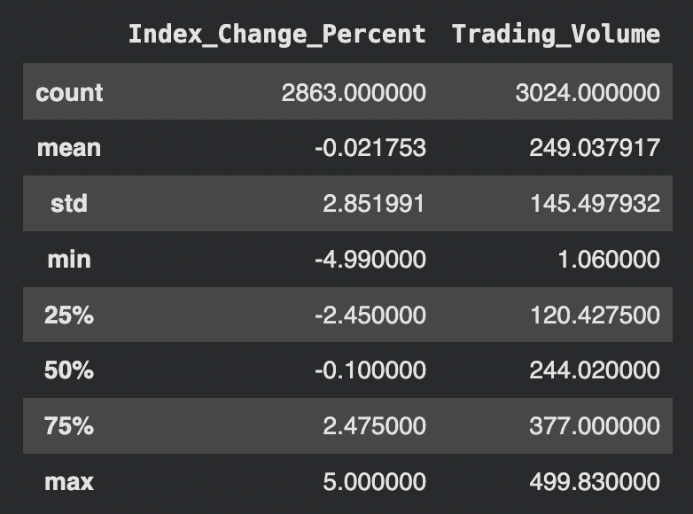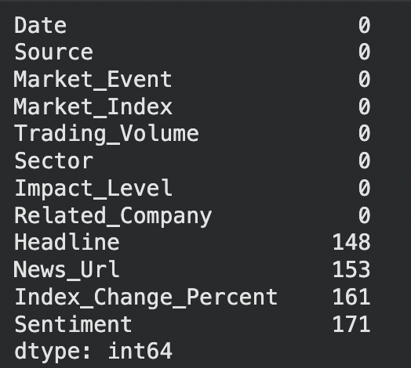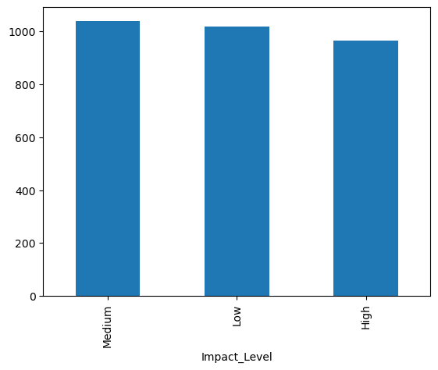

We can observe that our features include: Date, Headline, Source, Market_Event, Market_Index, Index_Change_Percent, Trading_Volume, Sentiment, Sector, Impact_Level, Related_Company, News_Url. We can observe the distribution of Index_Change_Percent is centered near zero, which indicates positive and negative movements. The range is also roughly between -5% to 5%, suggesting moderate market volatility as these are realistic daily index movements. Trading volume has a standard deviation of 145.497, which indicates diverse market activity levels. Additionally, most features have no missing values. However, missing values are present in Headlines, News_Url, Index_Change_Percent, and Sentiment. Since Headline is relevant to our project , rows with missing headlines will be removed during preprocessing. However, News_URl, is not required for modeling, so we will remove it entirely. From this chart, regarding impact level, we can observe that Impact_Level classes are well balanced, with each of the categories representing roughly 1/3 of the dataset. So, no class imbalance corrections (oversampling, class weighting) are needed.
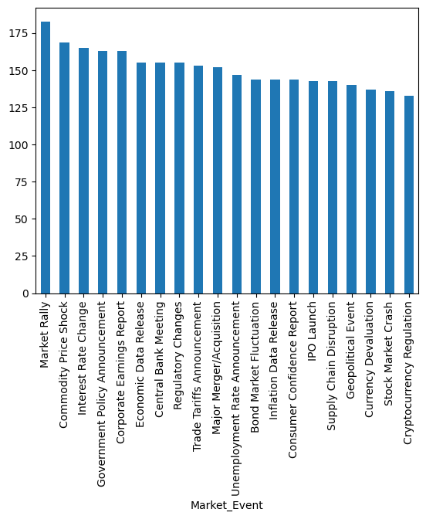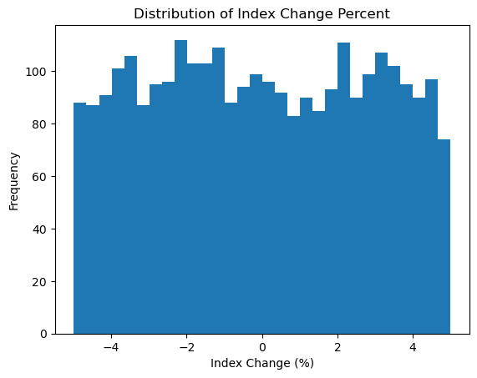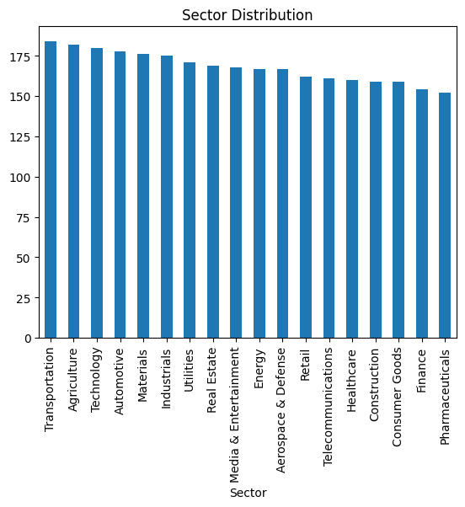

From this, we can observe that Market Rally has the most counts (roughly 18) out of all market events, and the lowest is cryptocurrency regulation. The rest of the events fall between 150-170. Additionally, the distribution of Index_Change_Percent appears approximately uniform with a range between -5-5%, with no strong skew toward positive or negative movements, suggesting a balanced market reaction across events and no significant outliers. Additionally, the sector distribution is relatively balanced across industries, with each sector contributing a similar number of samples. This balanced representation reduces the risk of sector bias in the model and supports generalizability across multiple market domains.

Overall this dataset is suitable for our financial news risk tagger as it contains structured event categories, market impact measures, sentiment labels, and connects textual news to quantitative marker reaction. It supports classification (through the column Impact_level), sentiment modeling, risk tagging, and event prediction. Since the dataset directly links financial news to measurable market reactions, it makes it well suited for developing a financial risk tagging pipeline.

Part 5: weekly work plan
Contributions so far + tentative weekly plan with member responsibilities
Rhea: Dataset
Dori: Motivation+Related Works
Fatema: Methodology

Podcast/youtube - extract audio part and convert to text - speaker’s name, statement, public activities on real-time basis
Multi-model
News from new york time, how news affects daily activities, stock decisions…

Reference:
https://dl.acm.org/doi/full/10.1145/3776759.3776941#:~:text=Firstly%2C%20a%20novel%20zero%2Dshot,before%20making%20a%20final%20judgment.

